

**2018 Michigan Music Research Conference**

**Welcome Packet**

I. Travel Information 2

Where are the Conference Events? 2

Getting to Ann Arbor 2

Getting around Town 3

Where to Park 3

Where to Stay 3

II. Where to Eat and Drink 4

Coffee 4

Food 4

III. Maps 5

# I. Travel Information

## Where are the Conference Events?

Maps of the University of Michigan’s North and Central Campuses are located on pp. 5–6 of this packet.

The majority of the conference events will be held on *North Campus* in the **Glenn E. Watkins Lecture Hall**. This lecture hall is located in the newly-renovated wing of the Earl V. Moore Building at 1100 Baits Dr., Ann Arbor, MI, 48109.

The Company Wang Ramirez performance will take place in the [Power Center](http://www.ums.org/venue/power-center/) on *Central Campus* at 121 Fletcher St., Ann Arbor, MI, 48109.

## Getting to Ann Arbor

Air Transportation:

Visitors traveling by air usually fly to the **Detroit Metropolitan Airport (DTW)**, which is situated about 30 miles east of campus. There are various ways to get from DTW to Ann Arbor:

1. **AirRide**

AirRide is an airport shuttle service managed by the Ann Arbor Transportation Authority in partnership with Michigan Flyer. One-way tickets cost $12 with an online reservation. Please visit [this link](http://www.theride.org/Services/Airport-Service) for more details.

1. **Taxi**

Taxi service from DTW to Ann Arbor is approximately $60. Recommended taxi companies include:

* Blue Car: (734) 547-2222
* Metro Cab: (734) 997-6500

Bus and Train Transportation:

1. [Greyhound Bus Lines](http://www.greyhound.com): (734)-662-5511. The terminal is located at 115 E. William St. in Ann Arbor.
2. [Amtrak](https://www.amtrak.com/home.html): (734) 994-4906. The station is located at 325 Depot St. The train connects to Ann Arbor from Toledo and Chicago.

## Getting around Town

Local Transportation:

1. **U-M Buses**

The University of Michigan offers a free bus system serving both the Central and North Campus areas. These buses run on multiple routes every 10–15 minutes and are the easiest way to get around. Fare is completely free for everyone, including visitors; simply hop on the right bus and find a seat! Visit [Magic Bus](http://mbus.doublemap.com/map/) to download the app and/or get information on bus routes and an interactive map of all buses currently in service.

1. **Ann Arbor Transportation Authority (AATA)**

Please visit <theride.org> for information on routes, schedules, and fares.

## Where to Park

On North Campus:

Parking is generally available in the lot adjacent to the Moore Building (Lot NC10). Visitors are allowed to park in any of the metered spaces (free on Saturday and Sunday) toward the back half of the lot.

In addition to the Moore lot, limited visitor parking is also available behind the Walgreen Drama Center (Lot NC27).

For both lots, park in one of the numbered visitor spots and pay by cash or credit card at the pay station on your way in. The rate is $1.60 per hour.

Metered parking is enforced from from 6:00 AM–5:00 PM, Monday–Friday in Lot NC10 and 6:00am–8:00pm, Monday through Saturday in Lot NC27.

On Central Campus:

Parking on Central Campus is often limited. Visit [this link](https://campusinfo.umich.edu/article/parking-0) for more details and maps of parking areas.

Free parking is available after 6:00 PM, Monday–Saturday and all day on Sunday.

Visit [this link](http://www.ltp.umich.edu/parking/visitors.php) for more information on visitor parking for both campuses

## Where to Stay

[Holiday Inn](http://www.hiannarbor.com/) (**734) 769-9800**

[Red Roof Plus+ Ann Arbor](http://www.redroof.com/property/Ann-Arbor/MI/48105/Hotels-close-to-University-of-Michigan-U-of-M-Ann-Arbor-I-94-SR-23/RRI045/) (**734) 996-5800**

[Hampton Inn Ann Arbor North](http://www.hamptoninnannarbor.com) (**734) 996-4444**

[Microtel Inn & Suites](http://www.microtelinn.com/hotels/michigan/ann-arbor/microtel-inn-and-suites-ann-arbor-plymouth-rd-/hotel-overview) (**734) 997-9100**  
[Holiday Inn Express](http://www.hiannarbor.com/) (**734) 761-2929**

# II. Where to Eat and Drink

## Coffee

On North Campus:

* Mujo’s Café at 2281 Bonisteel Blvd.
* Panera Bread at 1773 Plymouth Rd.
* Espresso Royale at 2603 Plymouth Rd.
* Songbird Café at 2707 Plymouth Rd.

On Central Campus:

* Comet Coffee at 16 Nickels Arcade
* Sweetwaters Coffee at 604 E. Liberty St.
* lab at 505 E. Liberty St., #300
* Espresso Royale at 322 S. State St.
* Roasting Plant Coffee at 312 S. State St.

## Food

On North Campus:

* Seoul Street at 1771 Plymouth Rd.
* Nagomi Sushi at 1754 Plymouth Rd.
* Cardamom Restaurant 1739 Plymouth Rd.
* Syrian Bakery 1721 Plymouth Rd.
* Mikette Bistro and Bar at 1759 Plymouth Rd.

On Central Campus:

* Slurping Turtle at 608 E. Liberty St.
* Arbor Brewing Company at 114 E. Washington St.
* Blue Tractor at 207 E. Washington St.
* Jolly Pumpkin at 311 S. Main St.
* Sava’s at 216 S. State St.
* Jerusalem Garden at 314 E. Liberty St.
* Zingerman’s Deli at 422 Detroit St.

# III. Maps

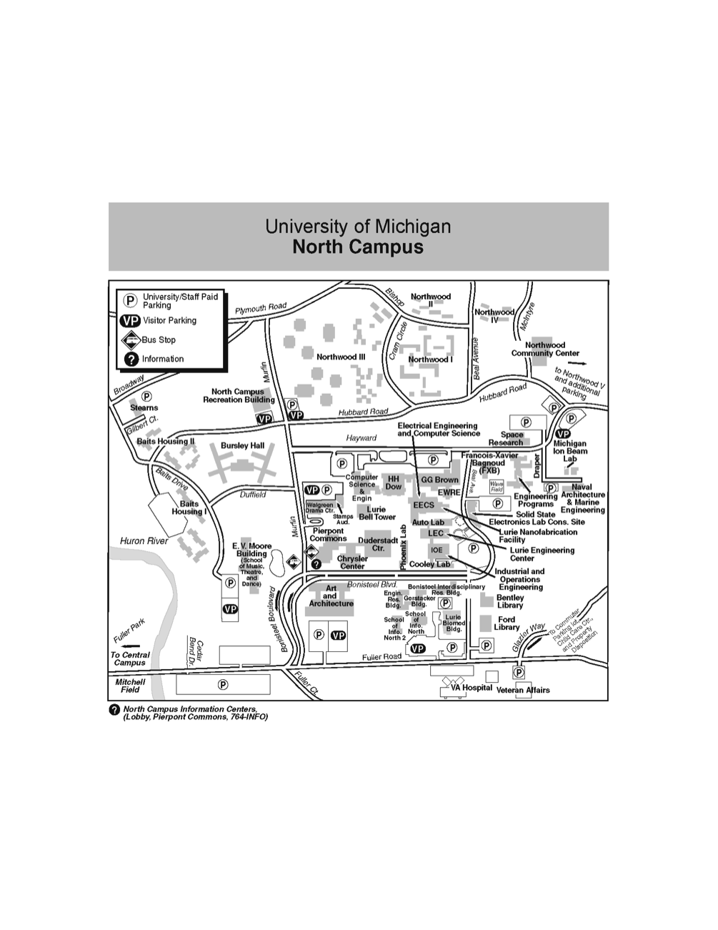

Macintosh HD:Users:vivianluong:Desktop:UMCentralCampusMap.pdf